**Exercise for back propagation**

Figure 9.5 shows a multilayer feed-forward neural network. Let the learning rate be 0.9. The initial weight and bias values of the network are given in Table 9.1, along with the first training tuple, X = (1, 0, 1), with a class label of 1.

This shows the calculations for backpropagation, given the first training tuple, X. The tuple is fed into the network, and the net input and output of each unit are computed

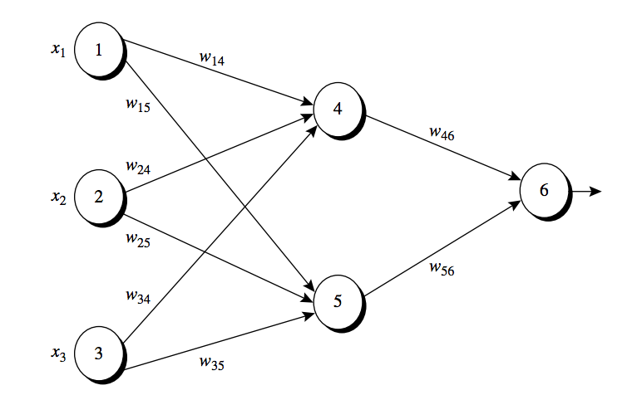

Figure 9.5 Example of a multilayer feed-forward neural network

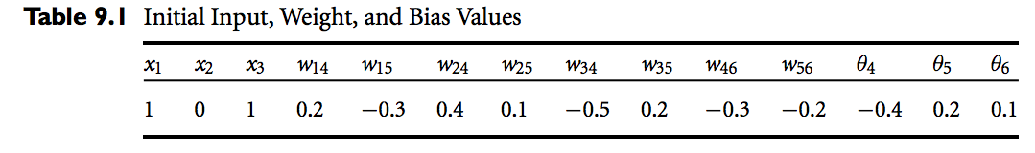

Activation function:

1. Please calculate the Net Input and Output



4 (1) * (0.2) + (0) * (0.4) + (1) * (-0.5) – 0.4 = (-0.7) 1/(1 + e 0.7) = 0.332

5 (1) * (-0.3) + (0) * (0.1) + (1) * (0.2) + 0.2 = (0.1) 1/(1 + e -0.1) = 0.525

6 (0.332) * (-0.3) + (0.525) * (-0.2) + 0.1 = (0.1) = 1/(1 + e 0.15) = 0.474

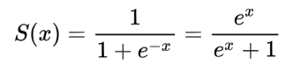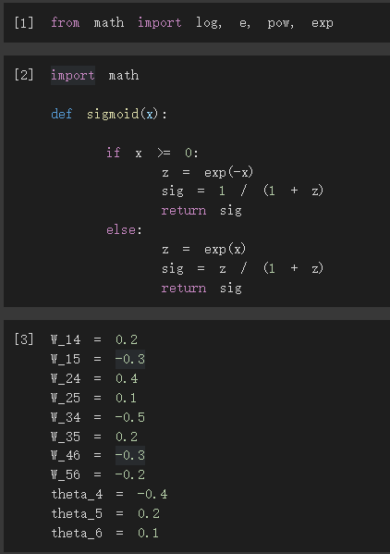

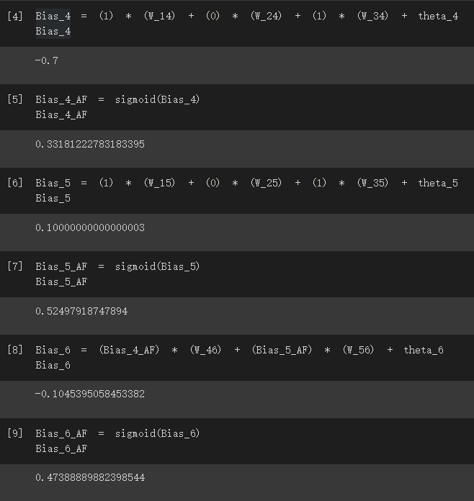

1. Calculation of the Error at Each Node

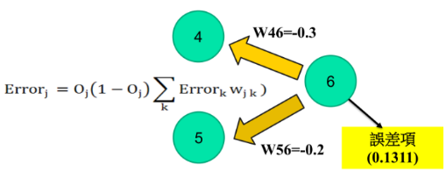

6 (0.474)(1 − 0.474)(1 − 0.474) = 0.1311

5 (0.525)(1 − 0.525)( 0.1311)(-0.2) = -0.0065

4 (0.332)(1 − 0.332)( 0.1311)(-0.3) = -0.0087

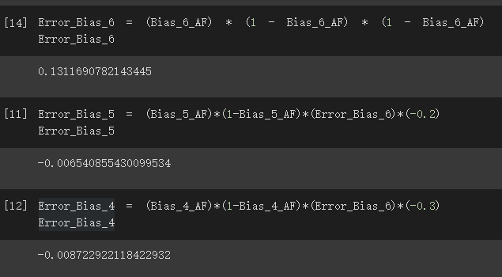

1. Please Calculate for each Weight and Bias Updating

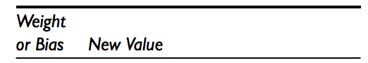

W14 = 0.2+0.9(-0.0087)(1) = 0.19217

W15 = -0.3+0.9(-0.0065)(1) = -0.30585

W24 = 0.4+0.9(-0.0087)(1) = 0.4

W25 = 0.1+0.9(-0.0065)(1) = 0.1

W34 = -0.5+0.9(-0.0087)(1) = -0.50783

W35 = 0.2+0.9(-0.0065)(1) = 0.19415

W46 = −0.3+(0.9)(0.1311)(0.332) = −0.261

W56 = −0.2+(0.9)(0.1311)(0.525) = −0.138

θ4 = -0.4 + (0.9)( -0.0087) = -0.40783

θ5 = 0.2 + (0.9)( -0.0065) = 0.91415

θ6 = 0.1 + (0.9)(0.1311) = 0.218

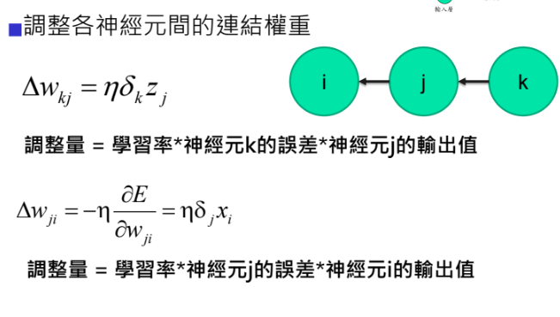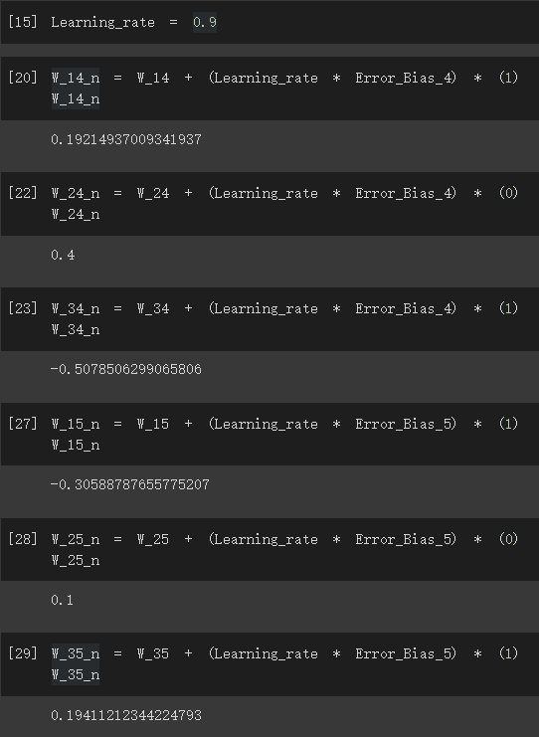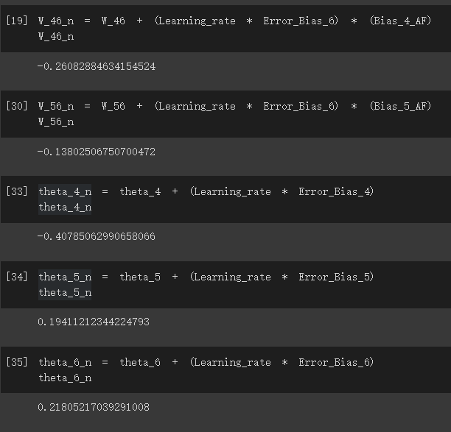

(參考公式)

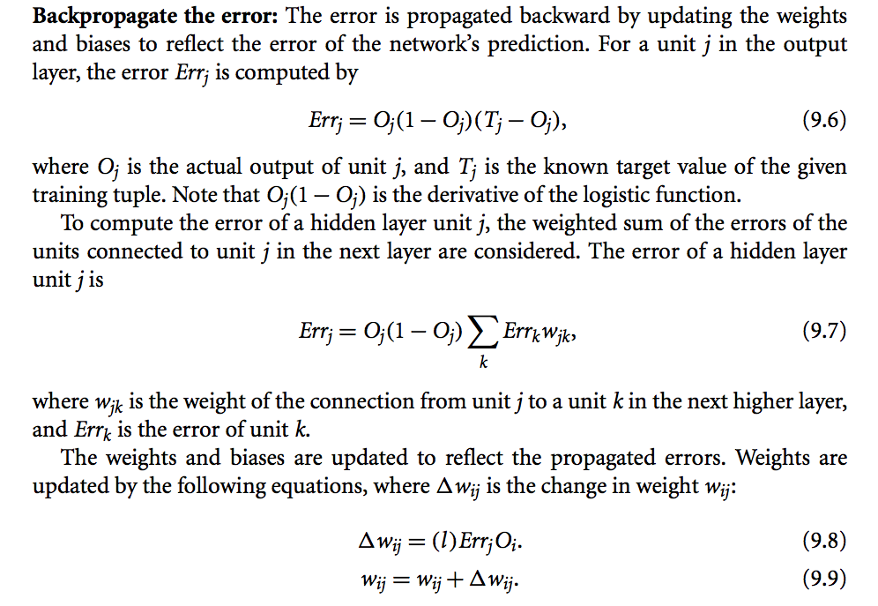

The variable l is the learning rate

